


Module Code & Module Title
CS6W50NI Career Development Learning

Assessment Type
Individual Learning Portfolio with Evidence
Semester
2025 Autumn

Student Name: Tapendra Singh
London Met ID: 23056247
College ID:
Assignment Due Date:
Assignment Submission Date:
Submitted To:
Word Count (Where Required):

I confirm that I understand my coursework must be submitted online via My Second Teacher under the relevant module submission portal before the deadline for my assignment to be accepted and marked. I am fully aware that late submissions will be treated as non-submission and a mark of zero will be awarded.

1.Introduction

1.1 Background to the Company
Due to interest and module in networking, IT systems, and technical support, I chose to have my internship in the company called Bhusal Tech Traders and Suppliers, which is a company that supply technical equipment and network-related solutions. This internship was primarily aimed at acquiring practical exposure and realizing how networking and IT support work is done in the real working settings. During my internship, I served as a Networking and IT Support Intern which exposed me to providing support to the technicians in system setups and configuration processes. I was engaged in the on-site network infrastructure and equipment checks, also helped with installations and helped to find out and address technical problems. Moreover, I was involved in remote IT services, where I used to chat and talk to clients via telephone and help them configure their systems and help them debug different technical issues. The internship had a significant value of enhancing my technical, communication, and confidence skills in performing real-world networking activities. It also provided me with sufficient experience on professional working practices and systems of client support. Overall, the experience has made a substantial contribution to both my academic and professional development as I was able to practice my theoretical knowledge in the field.

1.2 Structure and role of company
Bhusal Tech Traders and Suppliers is a technical trade and service-based company that aims at offering solutions to its clients regarding electronic solutions, networking and security services. The company is organized into several functional units that have the role of facilitating the smooth running of the organization, provision of technical services and customer satisfaction. The company is primarily divided into Sales and Procurement, Technical and Installation Support, Customer Service and Administration and Management departments. All the departments are significant to provide effective coordination among the supply of products, technical configuration, and after-sales services. Each section is manned by skilled personnel making the company to be responsive to the needs of the clients. Technical Support and Installation team is the one that performs the configuration, installation, and maintenance of the networking equipment and security systems, along with troubleshooting of the technical problems at the same location and remotely. The Sales and Procurement department deals with sourcing of products, coordination of suppliers and communication with the clients with respect to equipment demand. In the meantime, Customer Support team helps their clients by fixing their system issues by phone calls and technical support. Administration and Management department deals with daily operations and planning, as well as coordination of the workflow and quality of the services. The core business of Bhusal Tech Traders and Suppliers is to assist clients in the adoption of the reliable technological solutions through the provision of quality equipment, technical solutions and supportive services. The company is involved in enhancing the efficiency and reliability of the performance of the systems in its customers by integrating the supply of its products with practical technical services.
Organizational chart
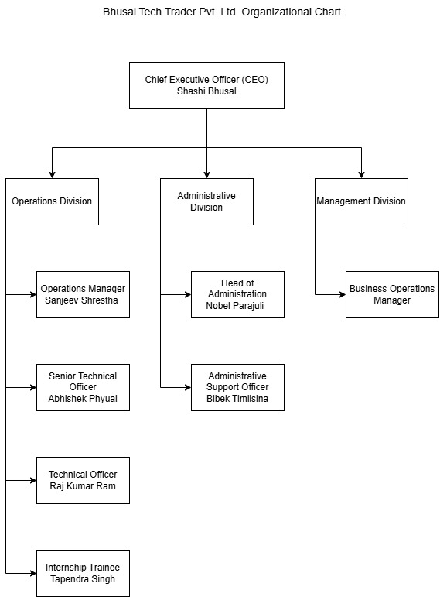
Figure 1: Organizational chart

1.3 Specific Department Worked In
My internship experience in Bhusal Tech Traders and Suppliers was mainly under Technical Support and Networking Department. This department would oversee installation, configuration, maintenance and troubleshooting of networking equipment and electronic systems that have been sold to clients. It is a significant contributor to the provision of technical services in an efficient way and a stable functioning of client systems. The Technical Support and Networking Department specializes in helping customers in configuring their systems, network connection, and system functionality. The team takes care of on-site and remote support and thus makes sure that the devices are well installed and configured based on the needs of the customers. I was also assisting technicians in the work of setting systems, monitoring the states of networks and equipment, and helping to eliminate typical technical and connectivity problems as an intern. Besides physical work, IT support is also offered by the department over the telephone. I served clients with the support of taking them through configuration processes, troubleshooting of the basic system failures, and providing solutions to their problems. This department equally works together with the sales team to make sure that before installation and deployment; the technical requirements have been well comprehended. The experience in this department enabled me to have a hands-on understanding of the operations in the networking field, dealing with customers, and real-time problem-solving. The exposure enabled me to build a practical skills base regarding the provision of technical support services in actual organizational contexts and enhanced my networking, system configuration, and IT support practices.

2. Academic Context
The academic module knowledge and skills were also significant to assist me in my internship activities at Bhusal Tech Traders and Suppliers. The modules were very theoretical and enabled me to acquire knowledge on networking, system security, and professional practices. The transfer of the classroom learning into real work situations helped me to better perform the technical activities and made me feel more confident when I was working on the technical issue in the real world during the internship.
Module 1: Computer Networks and Networking Fundamentals
This module offered a good base insight into the fundamentals of networking like IP addresses, network topologies, routing, switching, and basic troubleshooting of networks. The information that I acquired in this module was directly utilized in my internship as I worked with technicians to help solve network setups, troubleshooting network connections and evaluating network performance in the field. Knowledge of these networking essentials allowed me to detect typical networking errors and assist the clients in configuring and setting up the systems.

Module 2: Professional Issues, Ethics, and Computer Law
This module has made me realize the significance of professionalism, responsibility and legal issues in the IT world. This was put into practice during my internship not only in the processing of client information but also in the service delivery of technical support and professional communication with the customer. It was also able to aid me in adhering to organizational policies as well as proper utilization of technology when aiding clients in remote and on-site technical support.
Module 3: Risk, Crisis and Security Management.
The Risk, Crisis, and Security Management module was an eye-opener on the process of determining the technical risks, system vulnerability, and possible operational breakdowns. The knowledge was able to make me identify some of the common risks associated with networking equipment, system misconfiguration and equipment failure. In my internship, I used this knowledge in my work as I was able to help address troubleshooting problems and support technicians to minimize system downtime and increase service reliability. My capacity to respond effectively and calmly towards technical issues in the real working conditions was also developed with the help of the module.

3.Review of Activities

3.1 WRL Form
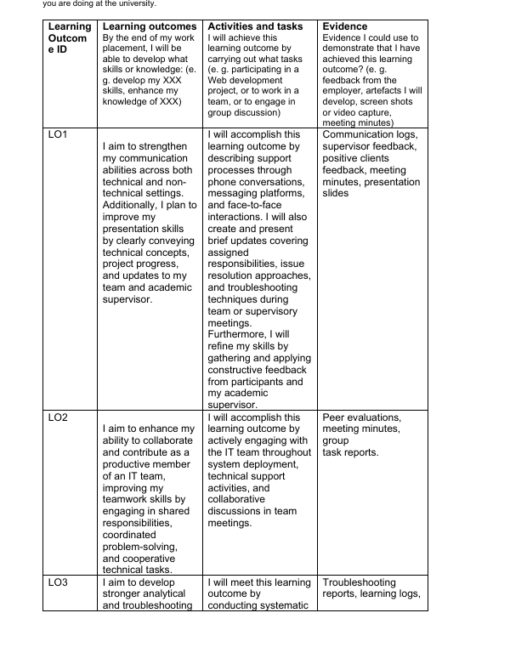
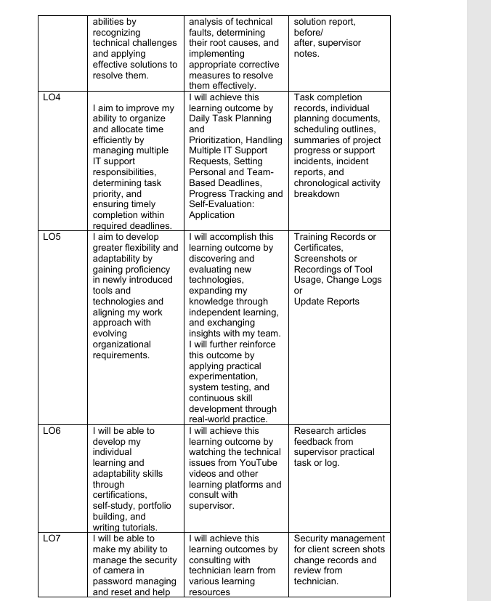
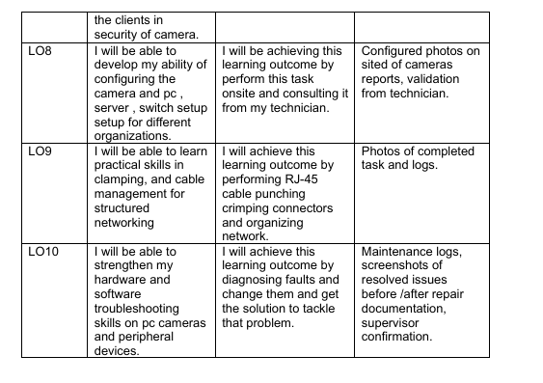
Figure 2:WRL Form

3.1LO1: I aim to strengthen my communication abilities across both technical and non-technical settings.
During my work placement, I enhanced my communication skills both technically and non-technically. I frequently made phone calls, used messaging services, and face-to-face communications with the team members, supervisors, and users. These contacts made me explain the processes of support and technical matters in a clear and professional manner. I was taught to change my style of communication based on the technical knowledge of the audience. To the non-technical users, I made technical concepts more straightforward. In the case of technical employees, I applied the right words to talk about system problems and troubleshooting techniques. My presentation skills also have been enhanced as I was able to provide short updates in team and supervisory meetings. These updates encompassed allocated tasks, project development, and problem-solving action plan. The frequent presentation training taught me to be more confident and understandable. I paid attention to logical structuring of information and its conciseness. I was also able to hear questions and answer them accordingly during the discussions. Supervisor comments enabled me to polish my style of communication. I used such feedback to become clearer and more professional. This experience helped to work with the team more efficiently. In general, I gained effective communication and presentation skills throughout my placement.
Evidence Log 1

3.2 LO2 I aim to enhance my ability to collaborate and contribute as a productive member of an IT team.
During my work placement, I managed to develop a greater skill in working as a productive member of an IT team. I was also involved in collective responsibility when deploying systems and undertaking technical support assignments. Collaborating with other team members helped me become more aware of teamwork in solving problems. I also helped to solve technical problems by means of mutual consultations and mutual troubleshooting. Team meetings helped in enhancing my communication and team-working abilities. I was taught how to appreciate different opinions and technical strategies in the team. I assisted colleagues when required so that the personnel could maintain the efficiency of workflow. I was also responsible in terms of doing tasks given on time. Technical activities were enhanced through collaboration, which enhanced service delivery. I adjusted to the team working conditions. Team building skills were enhanced by constructive feedback of team members. I used this feedback to improve cooperation and coordination of the tasks. The experience made me more confident when working in teams in terms of IT work. My level of responsibility in the team increased. Generally, the placement helped me become stronger in terms of teamwork and collaboration.
Evidence Log 2

3.3 I aim to develop stronger analytical and troubleshooting the problem.
During my work placement, I acquired greater abilities in analytical and problem-solving skills. I consistently found technical problems in the process of system operation and support. I used a step-by step method of troubleshooting to identify technical defects. This entailed the examination of symptoms and the examination of system settings. I identified root causes by isolating bad components or bad configurations. Rational thinking assisted me in assessing the potential solutions. I took suitable corrective actions to address the problems that were observed. To ensure that faults have been resolved successfully, testing was undertaken. I have also prepared notes on troubleshooting and notes, which would be useful in the future. Teamwork helped in addressing complicated problems. Problem solving practices were developed because of supervisor guidance. Mentoring facilitated the process of refining my analytical style. I had enhanced my skills of working under technical pressure. This experience strengthened my confidence on how to deal with technical problems. All in all, I enhanced my analytical and troubleshooting skills during the placement.
Evidence Log 3

3.4 I aim to improve my ability to organize and allocate time efficiently by managing multiple IT support responsibilities.
My time spent as a work placement provided me with effective organizational and time management skills as I had to handle several tasks related to IT support at the same time. I started out the day by planning my tasks, which enabled me to arrange my activities in terms of urgent, complex activities as well as deadlines. This was the planning that made sure that high-priority technical issues were done in time without causing delays in other support tasks. I also used to attend to various IT support requests of various users and that demanded effective switching of tasks and concentration. Scheduling personal and team-related deadlines helped me to be responsible and see to it that the tasks were done within the time limits. The use of progress tracking tools, task lists, and digital monitoring tools enabled me to track progress in completion and recognize delays in time. The self-assessment was important in enhancing my performance since I checked the already written tasks to determine efficiency and accuracy. My schedule changed when my priorities shifted or when some unforeseen problems occurred to ensure the productivity. The response of supervisors also contributed to the improvement of my planning strategies. On balance, this experience contributed greatly to my time management skills, as well as my ability to sustain the quality of service.

Evidence Log 4

3.5 I aim to develop greater flexibility and adaptability by gaining proficiency in newly introduced tools and technologies.
Flexibility and adaptability emerged during my work placement experience, as I was engaged in the active work on the newly introduced tools, new technologies, and new forms of organizational work. I also went out of my way and researched and tested these technologies as the organization was adopting newer systems and work processes to know how and why they were necessary. This was a proactive measure that made me adapt faster to technical changes and expectations in the workplace. I also broadened my knowledge base by conducting independent learning through reviewing of technical documentation, online materials and internal instructions. Moreover, I also shared my knowledge and experience with the team members frequently, and this facilitated group learning and enhanced my practical skills in learning new tools. Real-world application The real-world application scenarios were also attained through practical experimentation and system testing, where I was able to identify limitations and gain practical experience. My work approach was in line with shifting organizational needs by using these tools in my day-to-day activities. The real-life practice enhanced my confidence and technical competence. Supervisor feedback also helped me to develop. All in all, this experience improved my ability to adapt, my problem-solving attitude, and my willingness to study in the dynamic IT settings.

Evidence Log 5

3.6 I will be able to develop my individual learning and adaptability skills
My personal learning and adaptability skills were created by undertaking self-improvement exercises as I worked in a work placement. My knowledge was also improved through self-study through online learning websites like YouTube and other technical materials. Such websites enabled me to learn more about technical problems, tools as well as trouble shooting methods. I also had frequent meetings with my supervisor to discuss difficult issues and acquire some practice. I received feedback, which assisted me in directing my learning and enhancing comprehension with the help of my supervisor. In my case, I also worked on my professional portfolio, including writing about the tasks, solutions, and technical experiences. Composing brief tutorials and notes enhanced my learning and better understanding. My skills were also developed with the aid of certifications and organized learning materials. This self-directed learning helped me to be more flexible and self-confident in dealing with emerging technical issues. All in all, the placement enhanced my skills of learning on my own and using knowledge practically in practice in IT-based world.

Evidence Log6

3.7 I will be able to make my ability to manage the security of camera
My work placement has trained my skills in controlling camera security especially password management and reset. I also helped to ensure access to camera systems is secure since I adhered to the authentication and security rules. I was taught how to reset passwords in a safe manner without losing user information and system integrity. I was able to get practical experience of secure camera setting and access control by consulting with the experienced technicians. I also referred to different learning materials to learn best practices in managing camera security. These materials allowed me to realize the need of effective passwords and safe storage steps. The practical experience has made me more confident about my ability to help users with security problems with their cameras. It was guided by the supervisors to ensure that security tasks were done properly and in a responsible way. Overall, this experience helped me to gain better knowledge about camera security management and to improve my skills in supporting the work of the secure system.

Evidence Log 7

3.8 I will be able to develop my ability of configuring the camera and pc , server , switch setup setup for different organizations.
I also gained good technical capacity in setting up cameras, PCs, servers and network switches to various organizations during my work placement. I was also greatly involved in onsite installation and setup tasks thus offered me practical experience on IT environment in real world. This involved hardware assembly, connection of the network devices, IP addresses and proper connection of the systems. Through collaboration with other experienced technicians, I got to understand the procedures that are considered as standard configuration, security and the best practices that must be adopted to fit different organizational setups. The technician advice made me realize the difference in requirements based on different organizational sizes, network design, and operational requirements. I also had an experience in the troubleshooting of configuration problem during installation. System testing and verification was done to ensure that everything was working as expected. This practice led to my enhancement in confidence in the field and technical precision as well as being able to work on my own and be supervised. All in all, the placement enabled me to establish an ability of configuring and deploying IT systems in workplaces.
Evidence Log 8

3.9 I will be able to learn practical skills in clamping, and cable management for structured networking
During my work placement, I was able to acquire various skills in clamping, cables, and structured networking. For instance, I was able to acquire hands-on knowledge and understanding of how to organize and clamp network cables to enhance safety and efficiency. This involved planning and bundling cables appropriately and utilizing various clamping techniques to prevent tangling and damage.
I was able to punch RJ-45 cables and crimp connectors, which enabled me to create efficient and functional network cables. This provided me with extensive knowledge and understanding of various wiring techniques and the significance of signal integrity. In addition, I was able to acquire knowledge and understanding of how to label and organize cables appropriately to enhance network efficiency.
During my work placement, I was able to acquire various skills and knowledge in structured networking and cables through direct supervision and guidance from various technicians. This enabled me to apply my knowledge and understanding of network cables and efficiency to enhance my confidence and precision. This experience enabled me to become efficient in network management and installation while adhering to professional standards.

Evidence Log 9

3.10 I will be able to strengthen my hardware and software troubleshooting skills.
During my work placement, I focused more on improving my hardware and software troubleshooting skills, especially for PC cameras and peripherals. Generally, the major responsibilities of the work placement required me to identify faults, fix, or replace the faulty devices, and implement the solutions for solving the problems. I learned how to identify the causes of both hardware and software problems and implement the appropriate solutions. By actively working on these responsibilities, I gained experience in dealing with various types of device faults and learned better problem-solving techniques. I also gained more confidence in testing and evaluating the devices to ascertain whether they were working properly. These activities also helped me learn how to work methodically and effectively under time pressure. I also learned how to anticipate possible future problems. I gained experience working with various types of peripherals, which helped me gain more technical knowledge and flexibility. I also learned how to document faults and their corresponding solutions. This experience helped me apply the theoretical knowledge of IT in practical situations. I was able to gain an understanding of the interactions between hardware and software elements and their impact on the performance of devices. At the end of my placement, I feel that my understanding of troubleshooting has been greatly improved. I feel that I am better equipped to deal with technical issues in PC systems and peripherals.

Evidence Log 10

4.Abilities Evaluation

4.1 By the end of my work placement, I will be able to develop my project management and time management skills.
As I was doing my internship in Bhusal Tech Traders Pvt. Ltd., The high level of project management and time management skills have been achieved due to managing several technical tasks at a time. My on-site camera installations, remote customer support, documentation, and system configuration were all on-site and therefore needed proper planning. I also was taught to organize tasks according to the urgency, technical complexity and needs of the customers. The everyday task planning allowed me to set enough time to do installations, troubleshooting and report. I also liaised with technicians to have tasks done on time. Supervisory sessions ensured that I monitored my progress and made amends when necessary. The fact that I had to handle several calls with customers also helped me to work during a time crunch. Supervisor feedback helped me to understand how to be more effective with my scheduling techniques. In the long run, I became more effective in workload balancing. The experience helped me to handle the roles of a professional IT workplace.

4.2 By the end of my work placement, I will be able to develop my independent learning skills.
During the placement, I enhanced my independent learning capabilities by actively learning technical information. I went through the manuals of cameras, networking books and tutorials on internet to learn about system configurations. In cases where I encountered some unknown technical problems, I would initially seek the solution on my own. This strategy lessened the reliance on the human supervision. The self-study taught me new tools, cameras models, and problem-solving techniques. Independent learning made me accomplish tasks like camera set up and network testing among others with confidence. It also enhanced my flexibility towards new technologies. The level of my confidence was enhanced because I was able to practice concepts learned in real-life. This experience helped me to build on my skill of learning in a professional environment. The self-directed education was inseparable to my technical development.

4.3 By the end of my work placement, I will be able to develop my team collaboration and communication skills.
My internship greatly enhanced my teamwork and communication skills through continuous collaboration with technicians and supervisors. I actively participated in team discussions during installations and support tasks. Clear communication was required to coordinate installation steps and resolve issues efficiently. I regularly updated supervisors about task progress and challenges. I also communicated with customers through phone calls and online platforms such as Zoom. Explaining technical problems in simple language improved my communication ability. Feedback from team members helped refine my interpersonal skills. Working in a team environment taught me responsibility and cooperation. These experiences improved my ability to work professionally within group settings.

4.4 By the end of my work placement, I will be able to develop my critical thinking and problem-solving skills.
Critical thinking skills were developed when I was on the placement and performed diagnosis and solving of technical issues. I examined issues with camera connectivity, powering, network settings and errors of logging in. Rational thinking and logical reasoning were necessary in the identification of root causes. I considered various solution alternatives and then implemented remedial measures. Troubleshooting activities enhanced my decision-making capacity. I got to know how to evaluate risks and implement appropriate fixes. Supervisory comments were useful in clarifying my analytical skills. These experiences contributed to my efficiency in solving problems. I felt more at ease taking on technical issues on my own. Critical thinking was incorporated into my technical process.

4.5 : By the end of my work placement, I will be able to develop my technical skills in networking, camera configuration, and system setup.
I also developed my technical skills in networking and surveillance systems which were enhanced during my internship. I also had practical experience with installation of CCTV cameras, PCs, and switches. I got to know how to test the network connectivity and provide stable system performance. My knowledge about networking was developed through practical exposure to the PoE switches. Cable management and RJ-45 crimping were also practiced. These activities reinforced my knowledge on organized networking. I used theoretical knowledge in practical installations. The mentorship of the supervisor contributed to my technical precision. My level of trust in setting up the systems went up with time. This practice enhanced my practical IT background.

4.6: By the end of my work placement, I will be able to develop my customer support and professional service skills.
In my placement, I gained a lot of skills on customer support as I was in constant contact with the client. I helped customers with their camera problems, password recovery and setup advice. Listening to problems of the customers enhanced accuracy of issues being resolved. I used step-by-step solutions with phone calls and zoom. Communication with customers was made through professional communication which built trust. I have become a patient and simplified person in terms of explaining technical issues. There was supervisor coordination that facilitated delivery of support. The experiences improved my service orientation mindset. I gained a greater confidence in dealing with customer requests. The customer support was the key strength of my internship.

4.7: By the end of my work placement, I will be able to develop my adaptability and flexibility in a professional IT environment.
My internship necessitated flexibility to new technical settings and assignments. Every location of installation posed different challenges and system requirements. I adapted easily to new cameras models and settings. On-site learning assisted in enhancing flexibility. Continuous improvement was guided by feedback given by technicians. I had to change my methodology according to the organizational standards. The ability to be exposed to diverse tasks improved my learning rate. I got used to working in a dynamic environment. This flexibility enhanced my technical self-confidence. I needed to be flexible to support my professional growth.

4.8 By the end of my work placement, I will be able to develop my hardware and software troubleshooting skills.
I also gained good troubleshooting skills since I was able to diagnose hardware and software problems. I resolved issues related to cameras, PCs, and network peripherals. Having incorrect cables and misconfigurations were some of the things to be identified. I used procedural troubleshooting techniques to solve the problems. Cucuration of pre-and post-status enhanced accountability. The feedback of the supervisors improved my accuracy of troubleshooting. The practice enhanced my confidence. I acquired the skills of managing actual technical failures. Such competencies enhanced my IT support. Troubleshooting was one of my competencies.

5. Challenges
Challenges and issues are a vital aspect of professional development, since they are learning opportunities, and they contribute towards technical and personal development. When I was an intern at Bhusal Tech Traders Pvt. Ltd. as a Networking Intern, I have faced various issues that challenged my flexibility, ability to problem solve as well as my professionalism. Below some of the key challenges I had to deal with during this period are discussed.
• Time Management and Workload Balance.
Balancing between internship duties and College work was another major problem that I encountered during my internship as I had to work hard to ensure that I managed time well during those lessons. The internship was done on-site where I had to do installations, customer service calls, documentation, and learn new technical procedures that at times meant spending long hours working. Sometimes, the academic assignments interfered with the internship work so that it was hard to schedule everything properly. In the beginning, this caused stress and impacted my performance in terms of the efficiency of doing tasks. To counter this difficulty, I have come up with an organized routine of tasks I do daily putting importance and urgency in the forefront. I set aside certain time periods in which I was to do my internship activities and College work, and this allowed me to be more organized and achieve deadlines more efficiently. My supervisor was also very helpful in providing guidance and flexibility that enabled me to cope with the pressure of work. This experience enabled me to understand the value of time management to ensure productivity, reduce stress, and improve work results.
• Technical Troubleshooting and Practical Problem-Solving.
The other significant difficulty I had encountered during my internship was that of addressing real life technical problems unlike theoretical learning. There was also the need to make practical choices and fast thinking to troubleshoot issues associated with CCTV cameras, network connectivity, power issues and device configuration. In others, issues arose unanticipated during installations or even in customer service calls, that needed to be resolved instantly, yet with a professional disposition. To cope with this issue, I had recourse to systematic troubleshooting techniques such as problem root cause identification, testing settings and supervisor consultations as required. As time went by, the frequent experience of technical problems made me more confident and capable of overcoming the issues on my own. This experience helped to reinforce my analytical competencies, as well as to learn how theoretical concept can be used in real-life situations. If the company has a client and is not technical, communication with the client will be required, as well as communication with non-technical users. Communication with Clients and Non-Technical Users. If the company is not technical and has a client, communication with the client will be required, and so will non-technical users. Another problem that I faced on the internship was in communicating technical information to clients with limited technical knowledge. Customers tended to be unable to articulate problems and struggled to comprehend technical descriptions of camera systems and network arrangements. This occasionally resulted in misunderstanding or stalling of problems. To overcome this obstacle, I was taught to make complex technical descriptions simple and step-by-step instructions easy and understandable. The interaction and clarity were enhanced using phone calls and the internet like Zoom. I gained confidence in the way I dealt with customer questions and assistance in technical matters with a practice. This experience helped me to develop my skills in communication and become a better professional collaborator with different users.
• Advancing to the New Tools and Technologies.
The internship setting made me be fast to grasp the new models of cameras, networking devices, and systems configuration. First, it was not easy to know various device interfaces and working procedures, particularly when there was a combination of many technologies at the same time. Different installations sites had their own peculiarities, and they had to be flexible and learn fast. To cope with this dilemma, I also resorted to doing independent studies through looking at manuals, online tutorials and instructions of technicians. Real-life experience and practice made me familiar with new tools and technologies. The task helped me realize that flexibility and constant education are the keys to the success in the IT sector that is crucial to further professional development.

6.Conclusion

7.Future work

8.Appendix

8.1 CDL Form
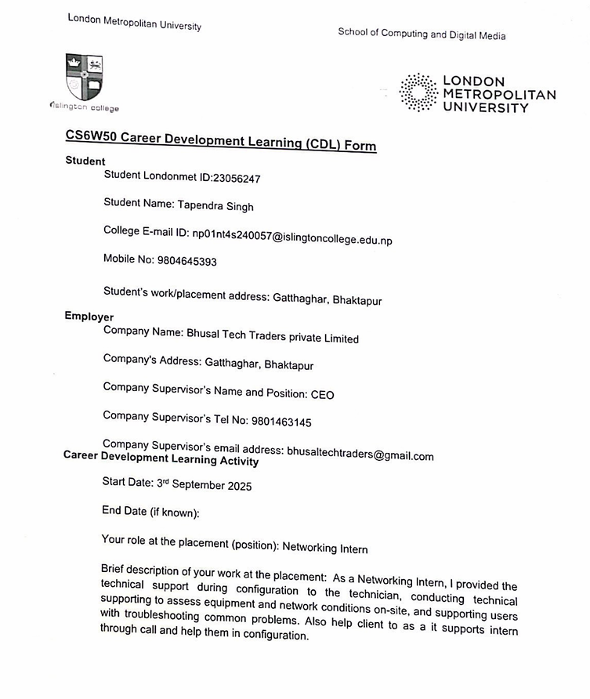
Figure 3: CDL Form [Page 1]

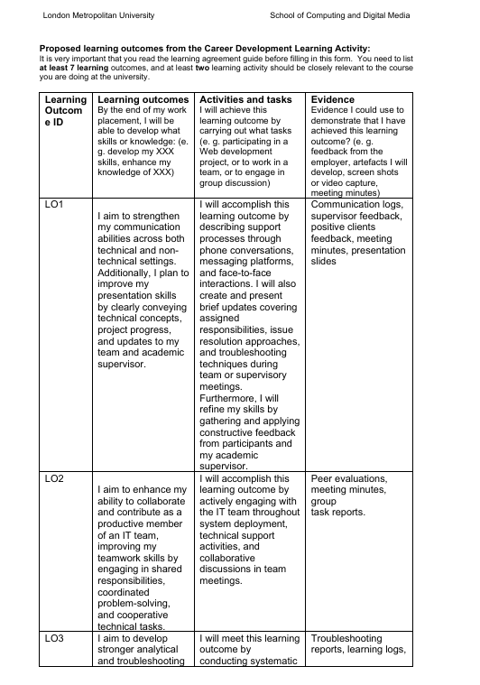
Figure 4:CDL form [page:2]

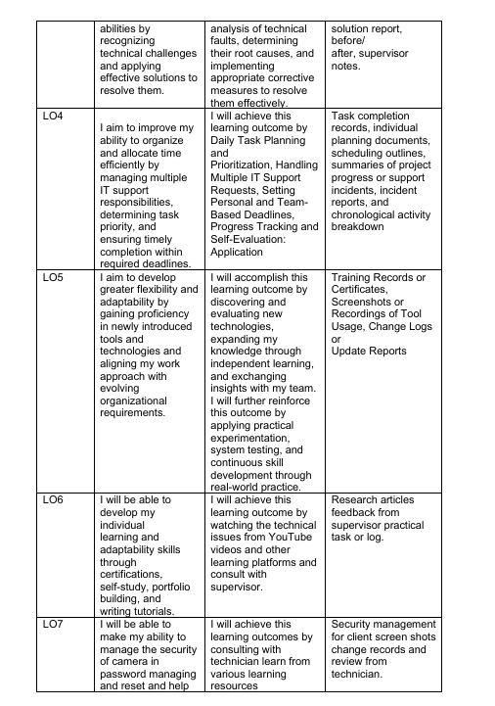
Figure 5:CDL form [page 3]

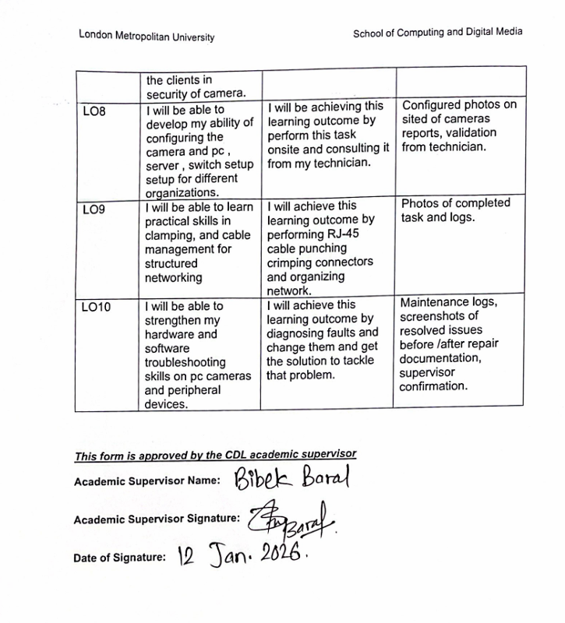
Figure 6: CDL Form [page4]

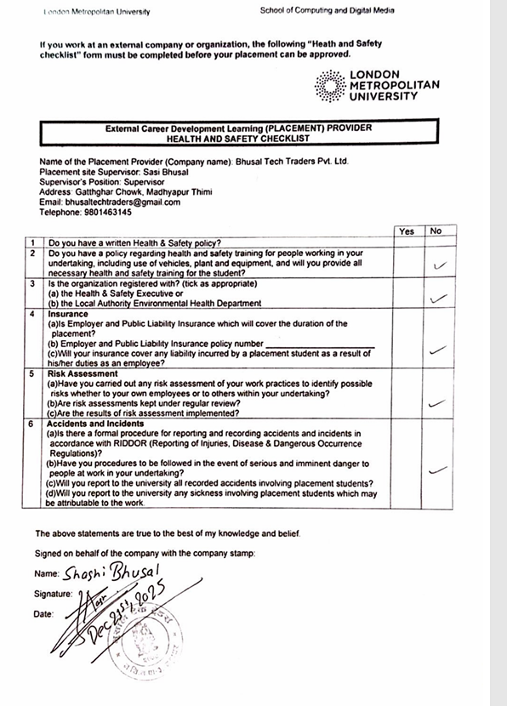
Figure 7: CDL Form [Page 5]

8.2 Attendance sheet
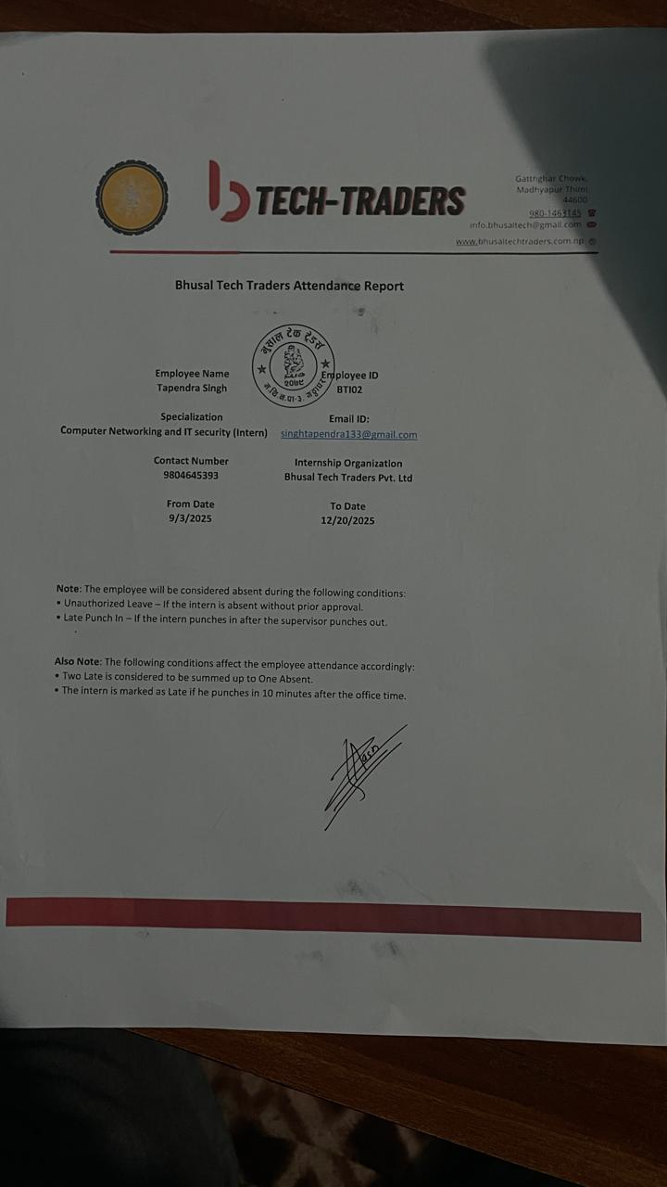
Figure 8: Attendance sheet [page 1]
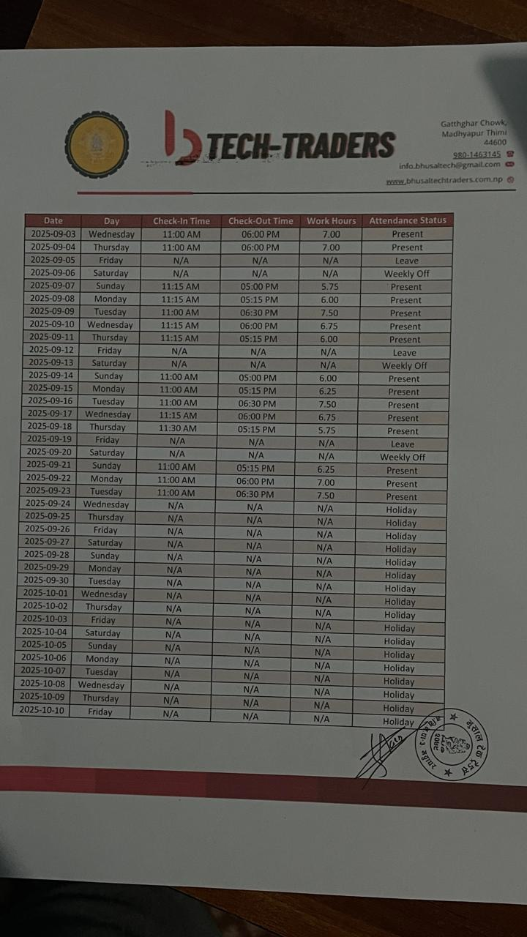
Figure 9: Attendance Sheet [page 2]

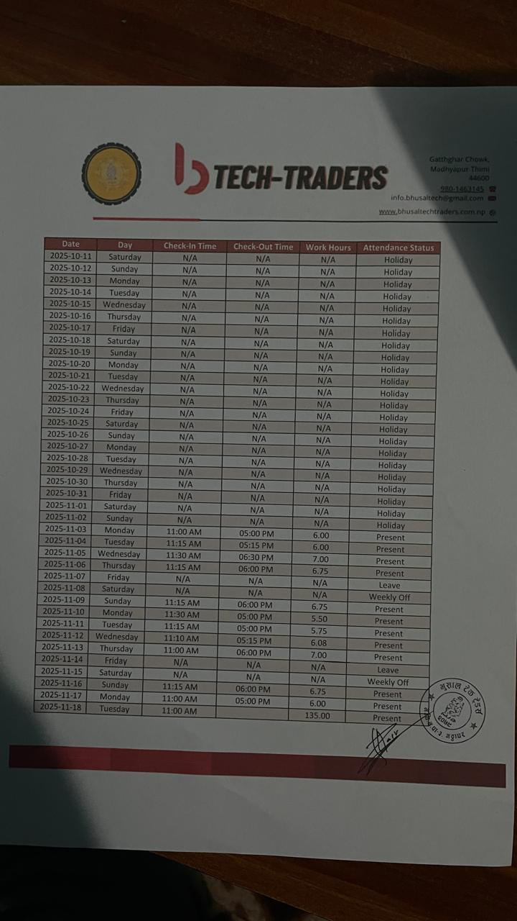
Figure 10: Attendance Sheet [page 3]
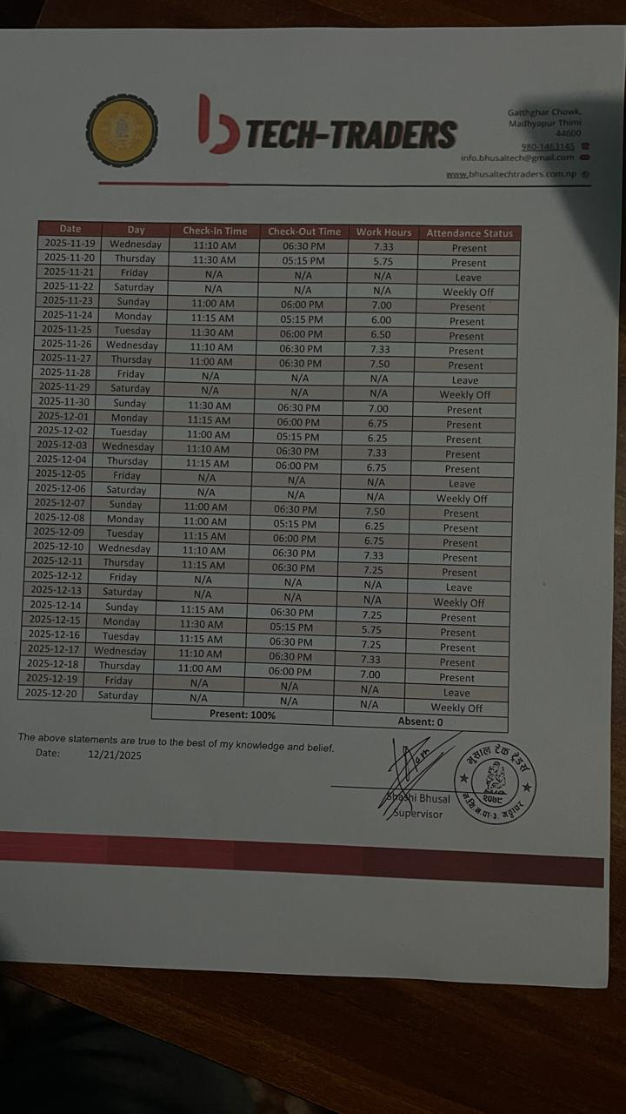
Figure 11: Attendance sheet [page4]

8.3 Internship Completion Certificate
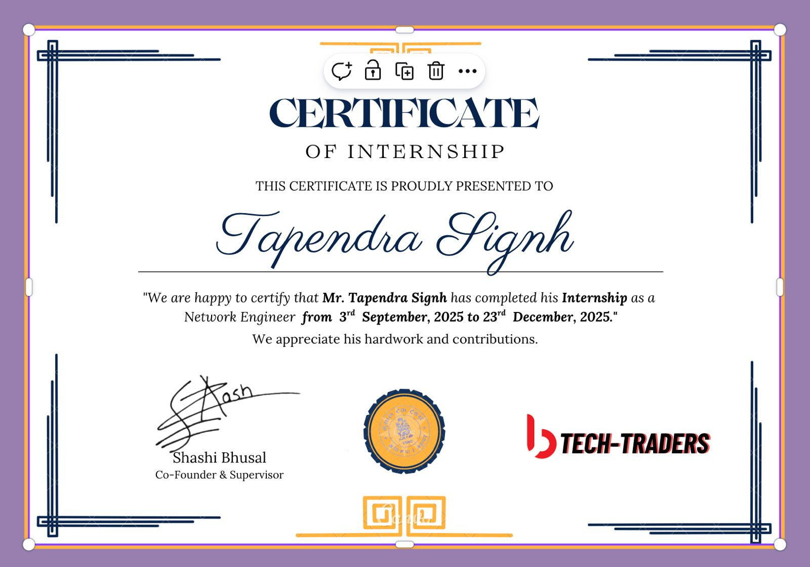
Figure 12: Internship Completion Letter

8.4 CV (After Internship)
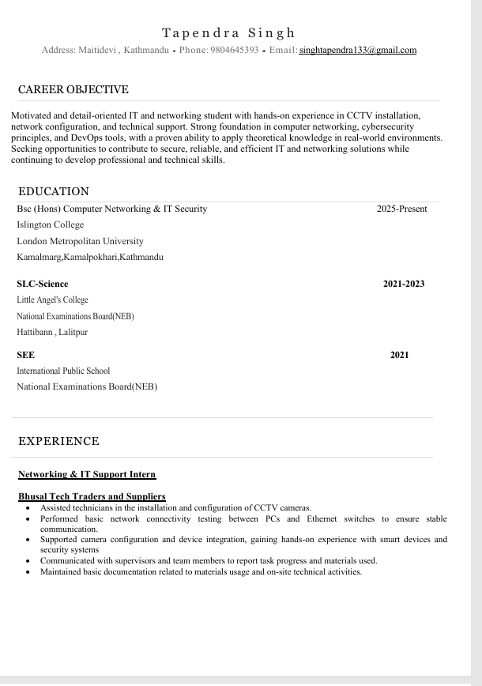
Figure 13: CV page1

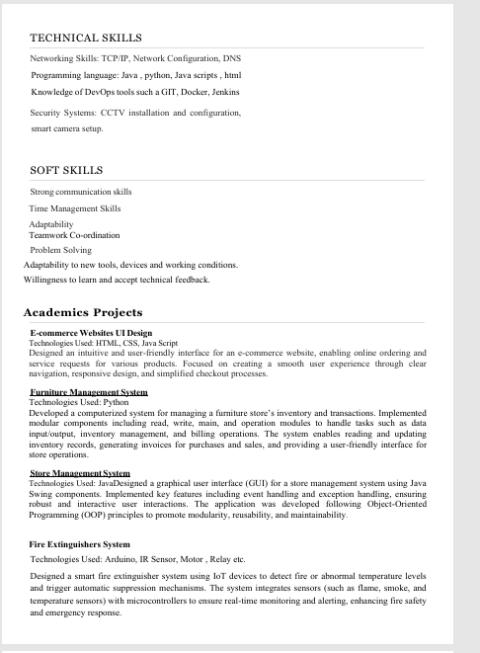
Figure 14: CV page 2

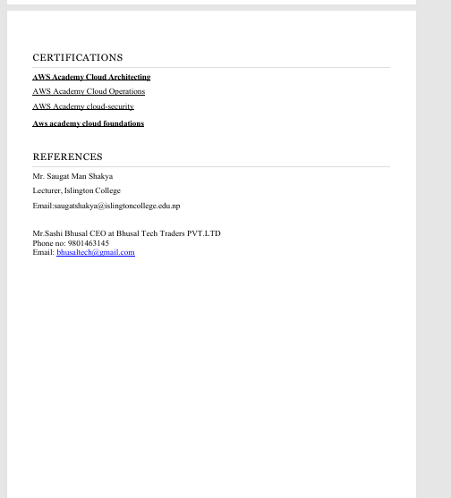
Figure 15: CV page 3

8.5 Evidence

8.5.1Log1
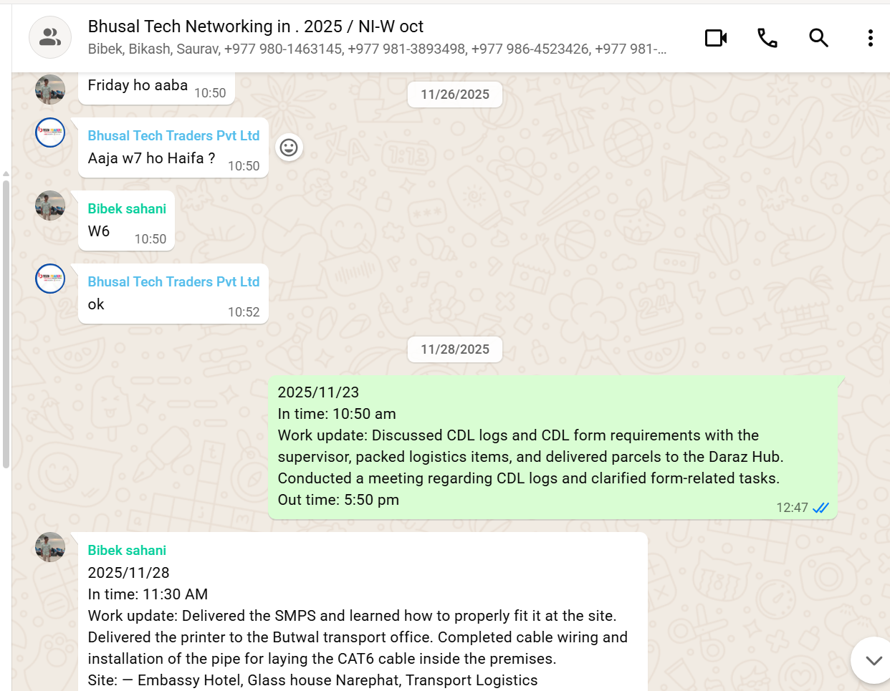
Figure 16: Chat logs of whatsapp

This picture shows a WhatsApp group conversation used for internship coordination and daily work reporting at Bhusal Tech Traders Pvt. Ltd. the image demonstrates professional communication, accountability, real-time task reporting, and practical exposure to both technical and operational responsibilities during the internship period.

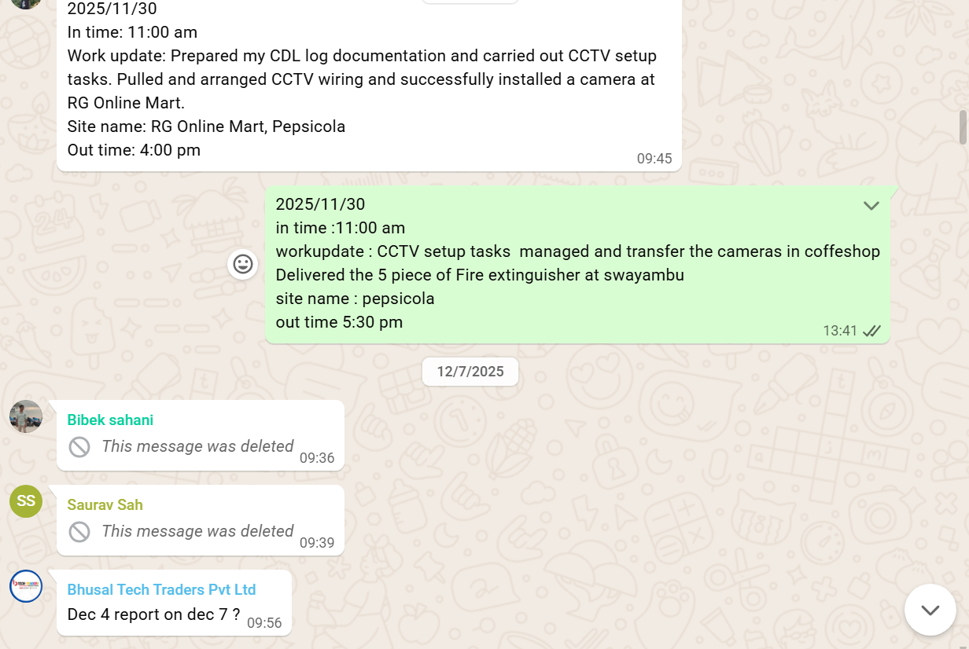
Figure 17:Chat logs of intern of group

This image shows a daily internship work log and task confirmation shared through the official WhatsApp group of Bhusal Tech Traders Pvt. Ltd. the image illustrates consistent daily reporting, hands-on technical experience in CCTV systems, effective coordination with supervisors, and professional engagement in both technical and operational tasks during the internship period.
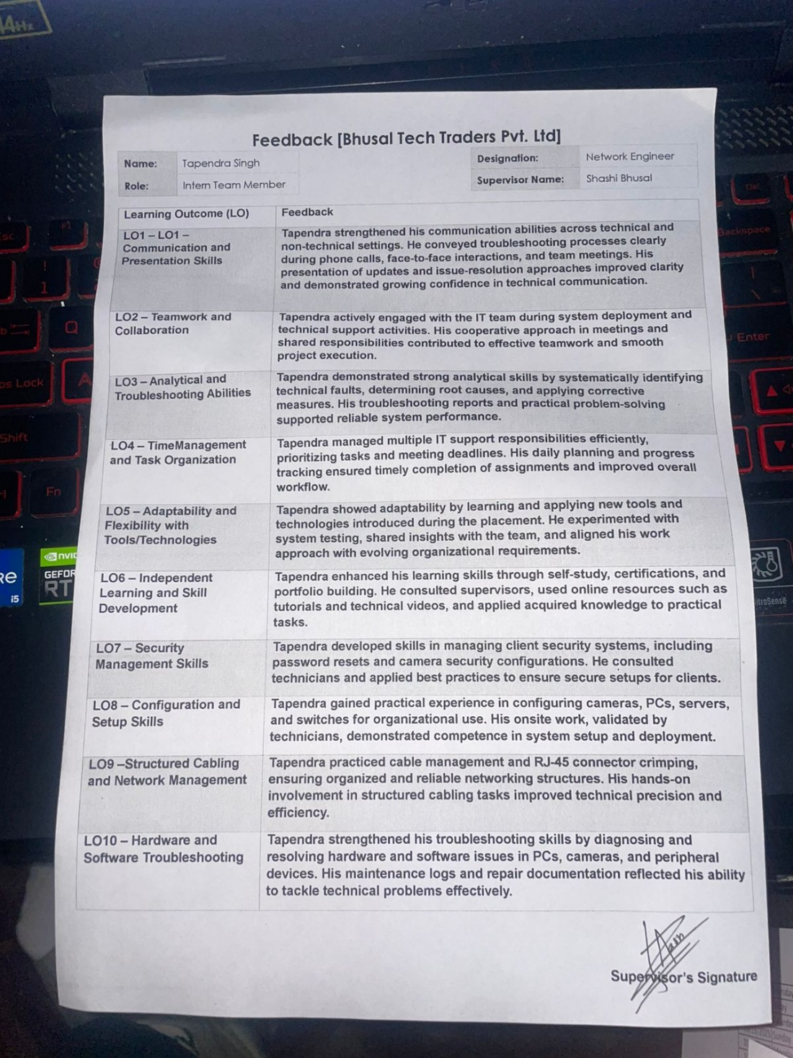
Figure 18: Feedback report

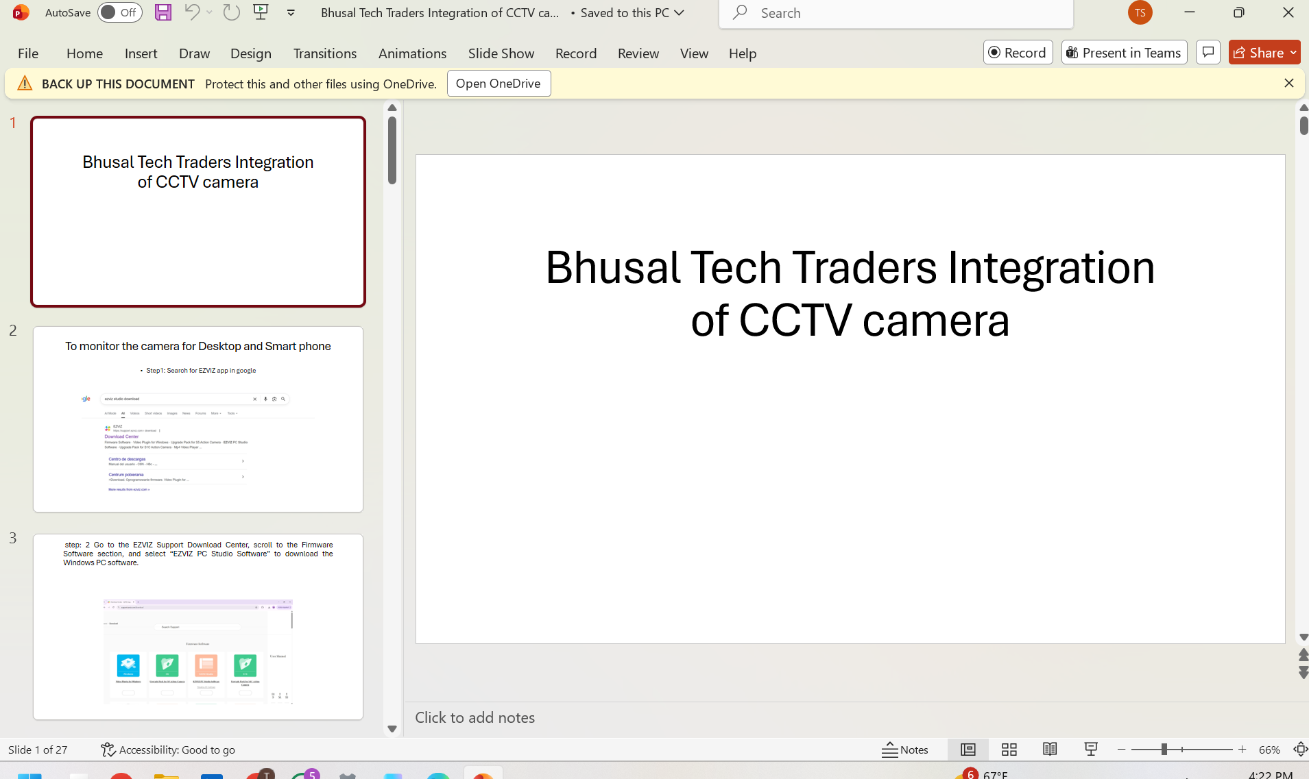
Figure 19:Presentation slide
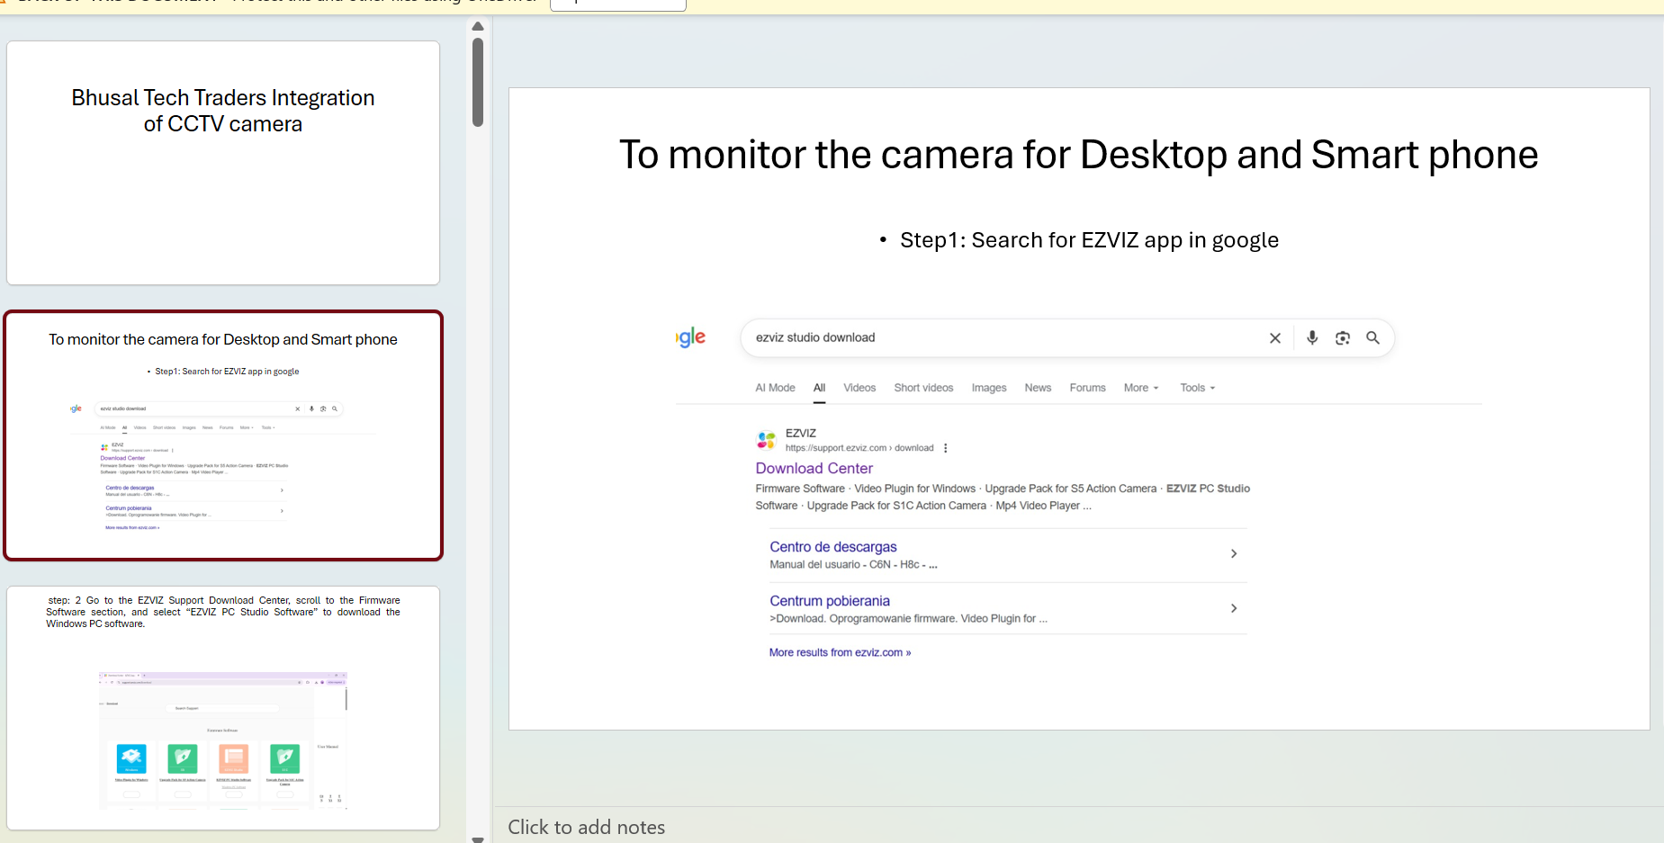
Figure 20: presentation slide 2
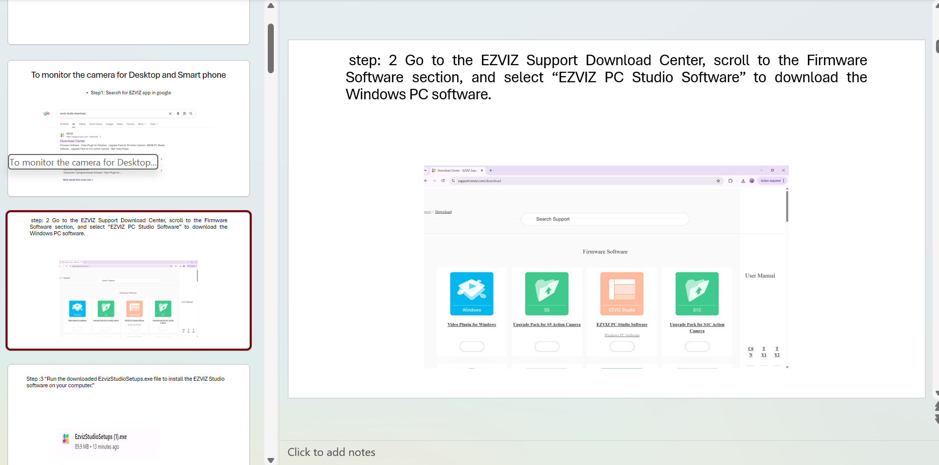
Figure 21:presentation slide 3

8.5.2 Log2
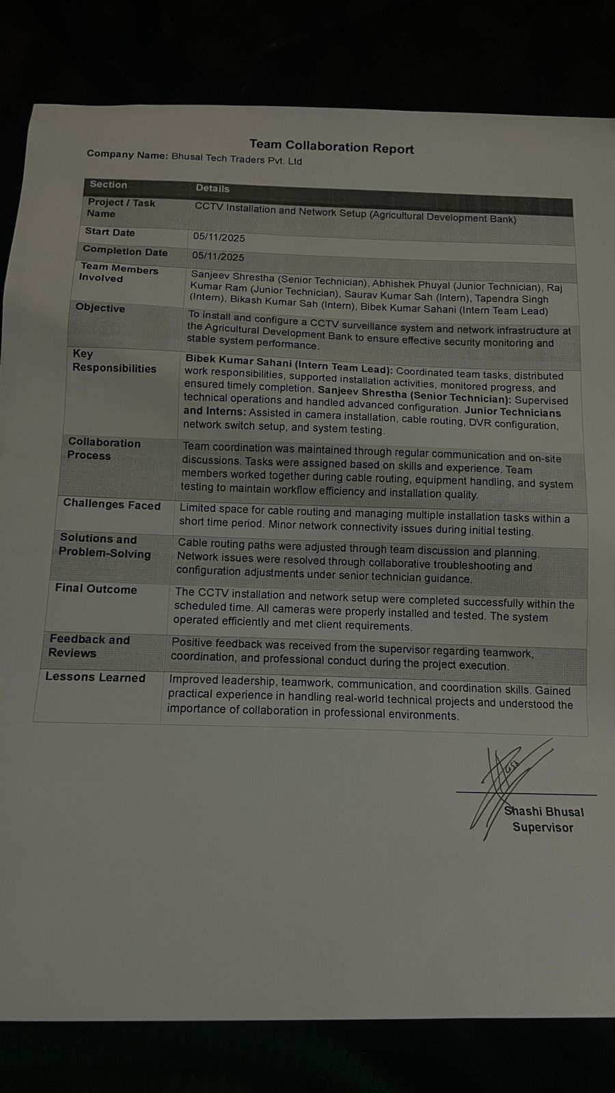
Figure 22:Team Collaboration Report

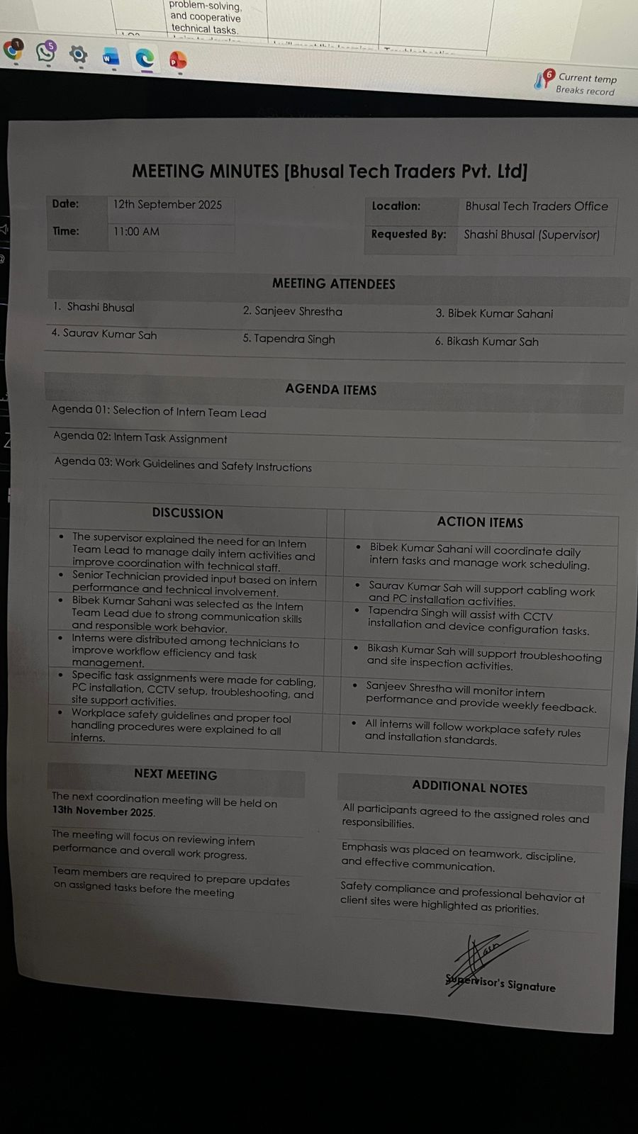
Figure 23: Meeting Minutes

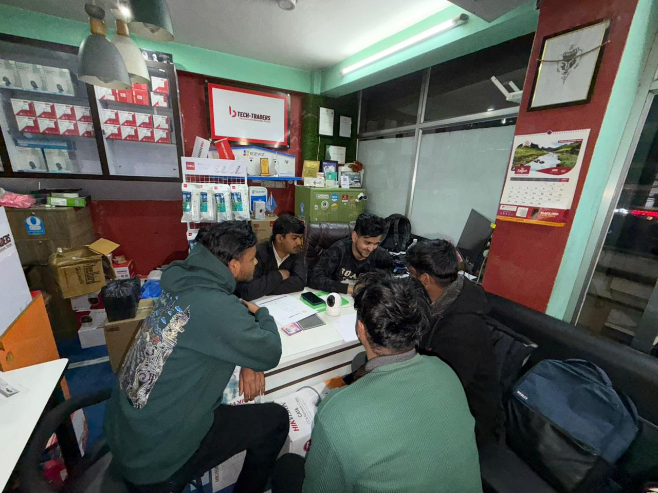
Figure 24:Picture of meeting with supervisor

8.5.3 LO3

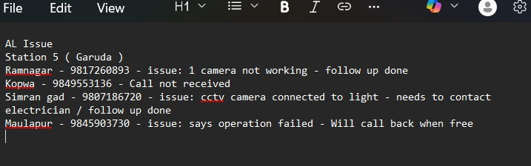
Figure 25: Notes of issues of clients provided by supervisor
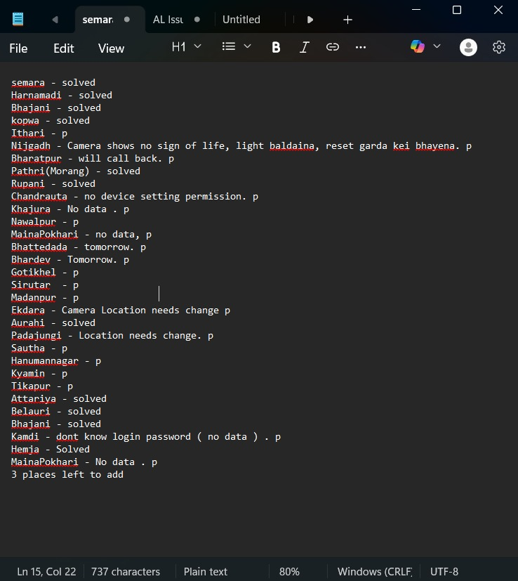
Figure 26: Issues solved status note after task

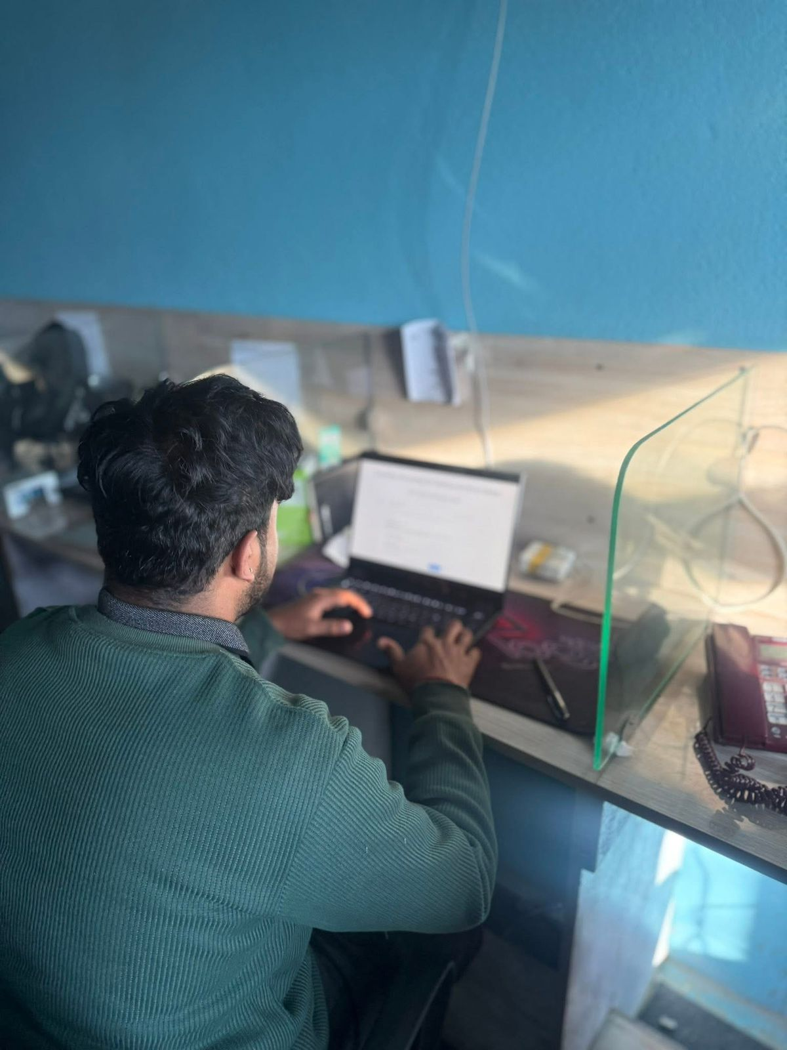
Figure 27: Solving issues of clients through by online guide them to solving the issue

8.5.4 Log4
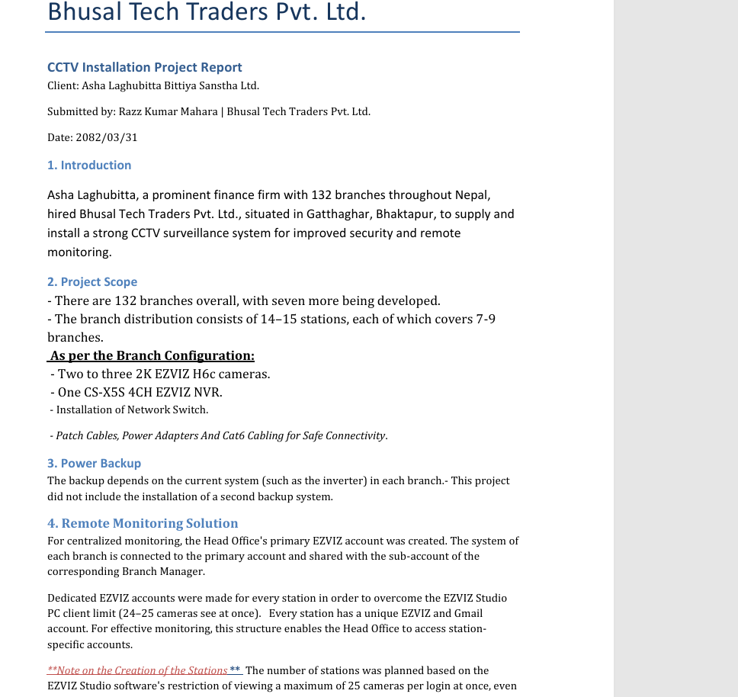
Figure 28:Project report of asha Laghubitta

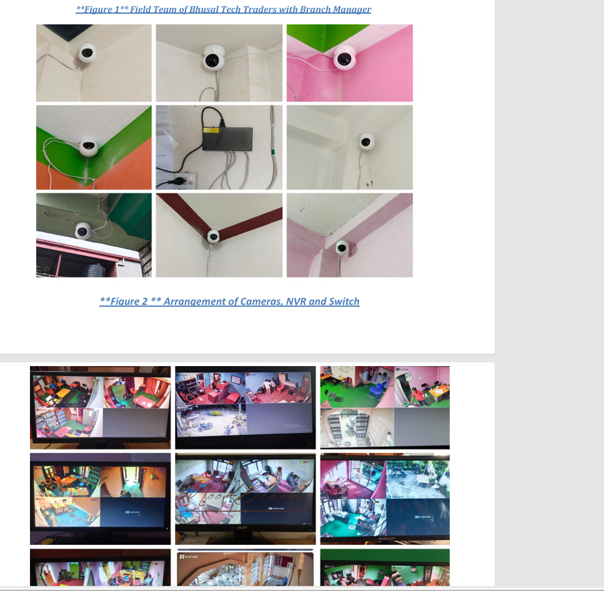
Figure 29:Status of task of asha laghubitta project

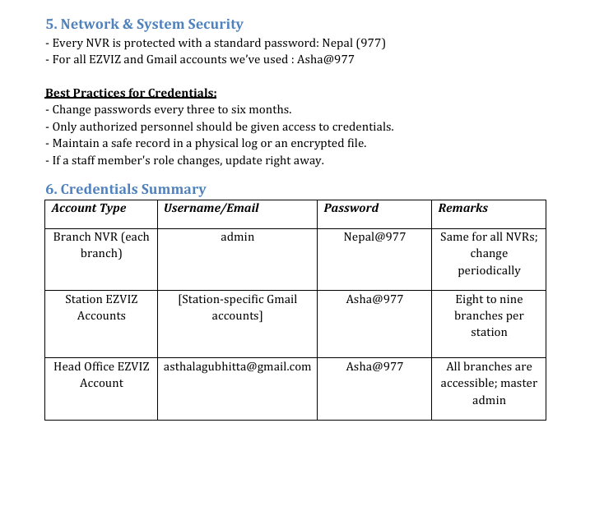
Figure 30: project report of task status and record

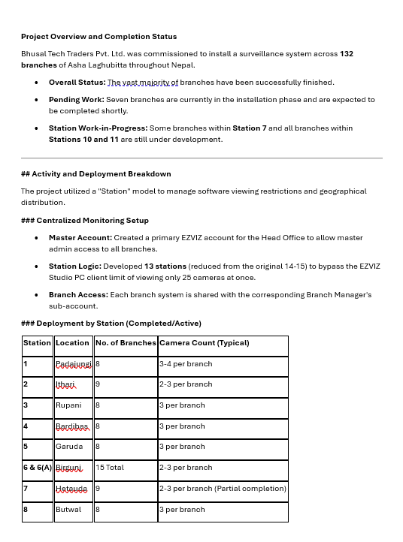
Figure 31:Report of progressing task

8.5.5 Log 5
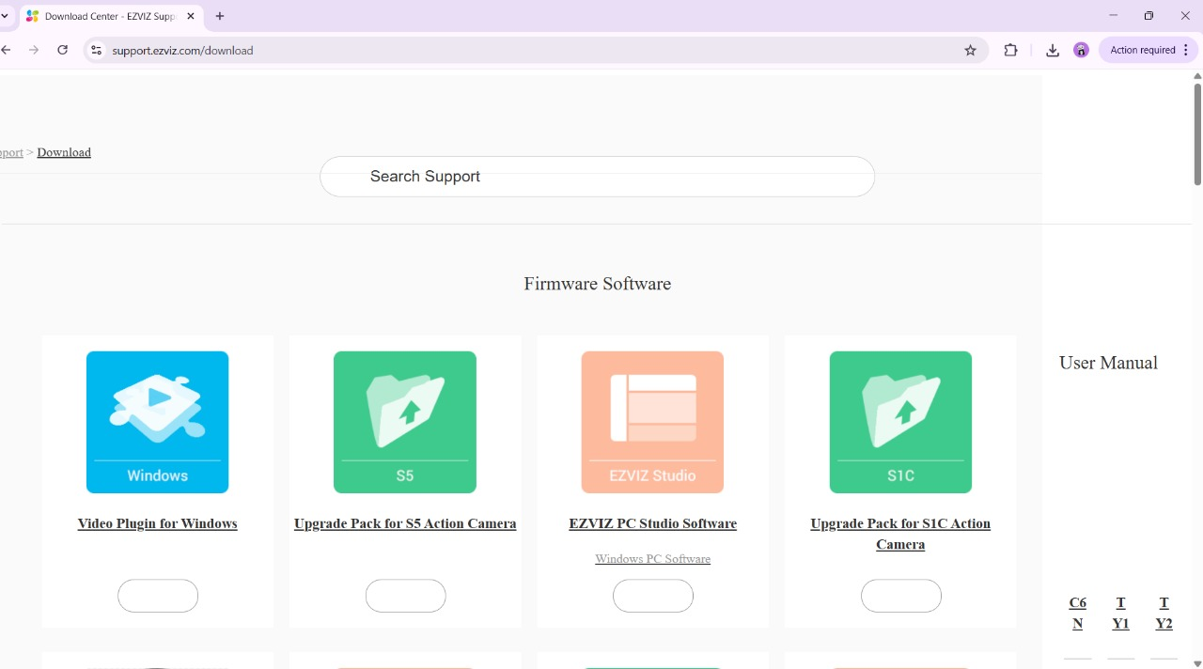
Figure 32:Downloading the ezviz tool

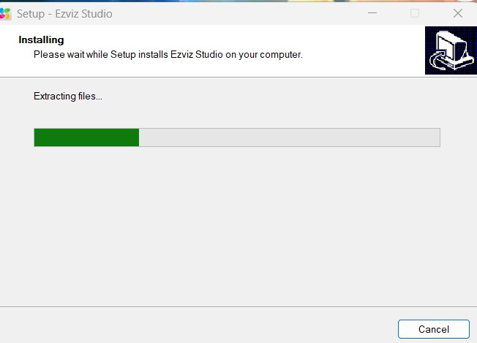
Figure 33: Installing the Ezviz tool for camera setup

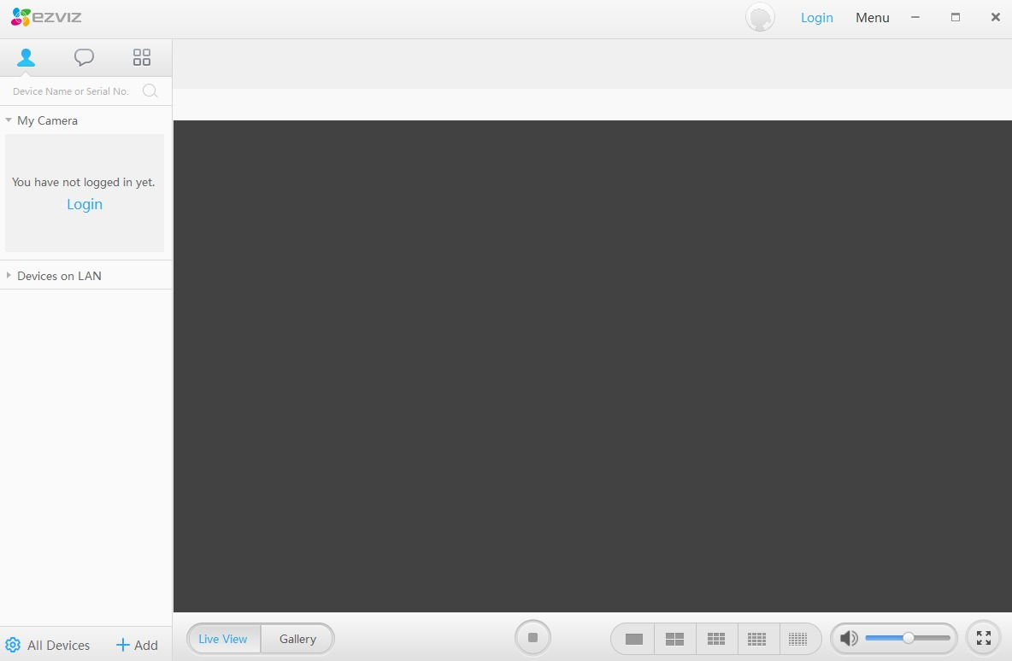
Figure 34: Home screen of EZVIZ

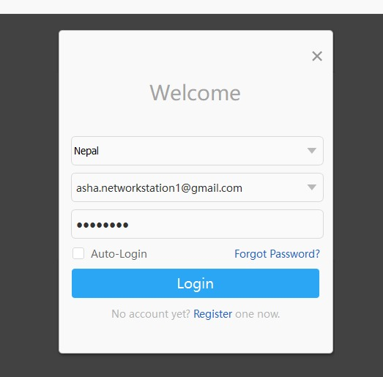
Figure33: logging in EZVIZ

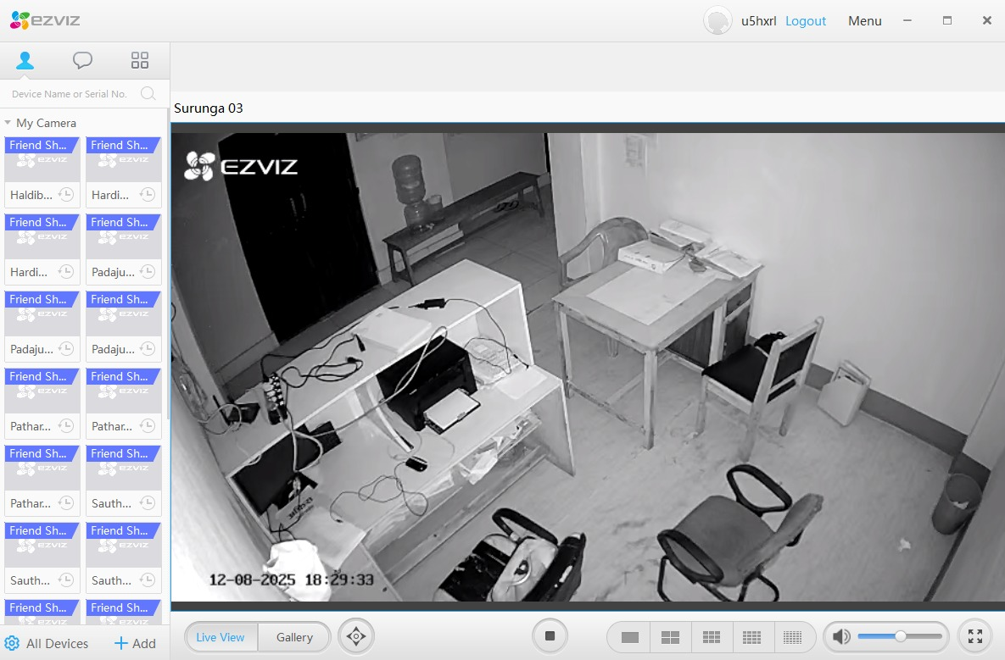
Figure34: Successfully showing the recordings and videos on EZVIZ

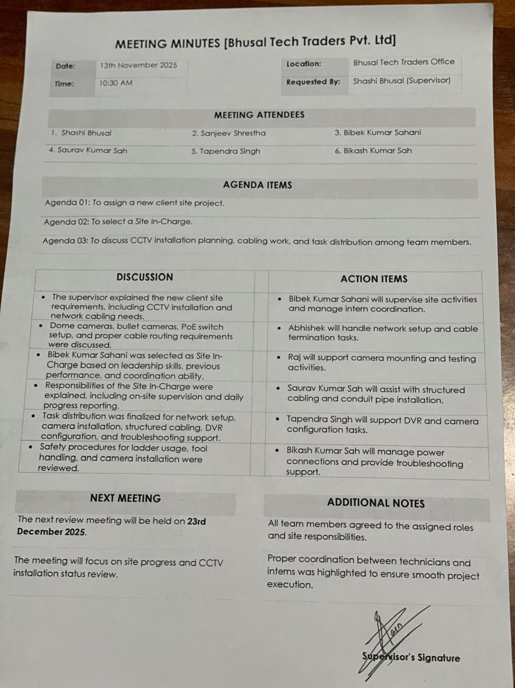
Figure 35:Meeting minutes 2

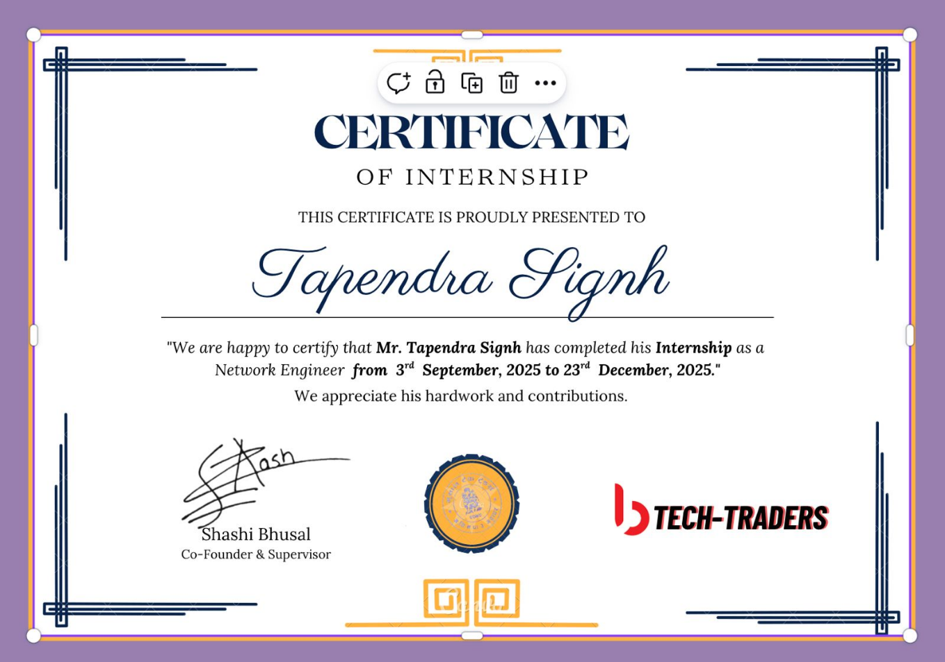
Figure 36:Certificate of Intern

8.5.6 Log6
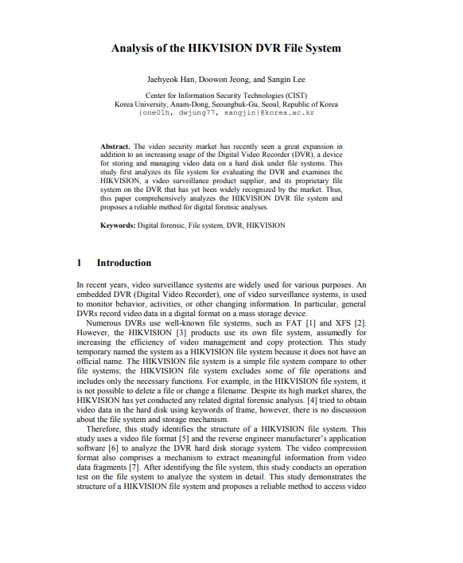
Figure 37:Articles of guidance of Hikvision 1

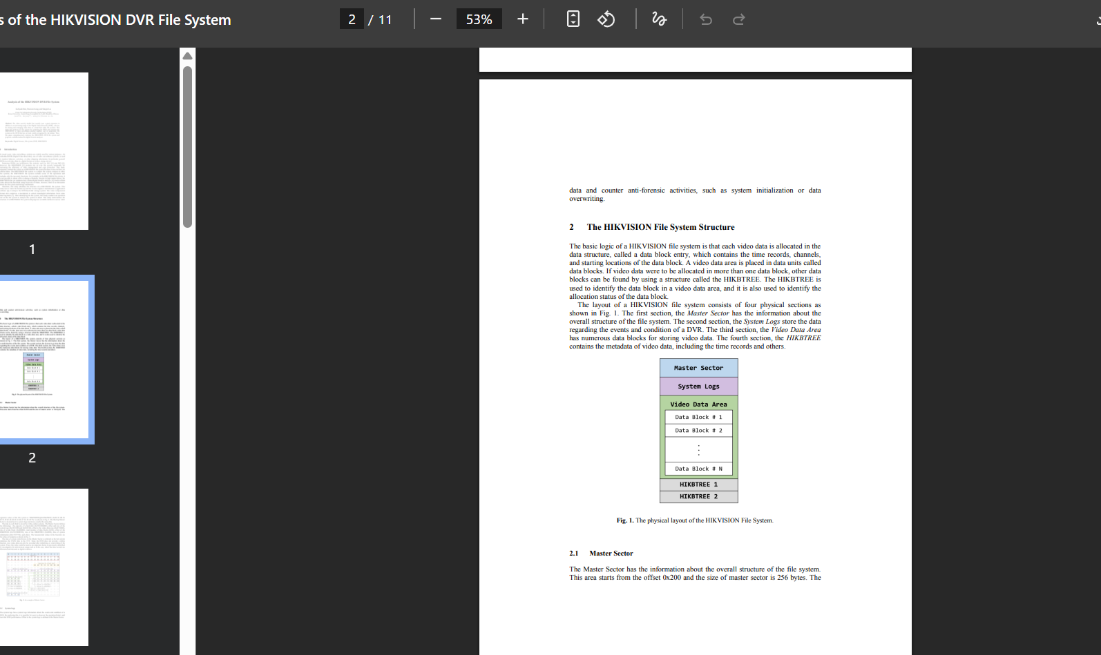
Fiigure 38:Articles of guidance of Hikvision 2

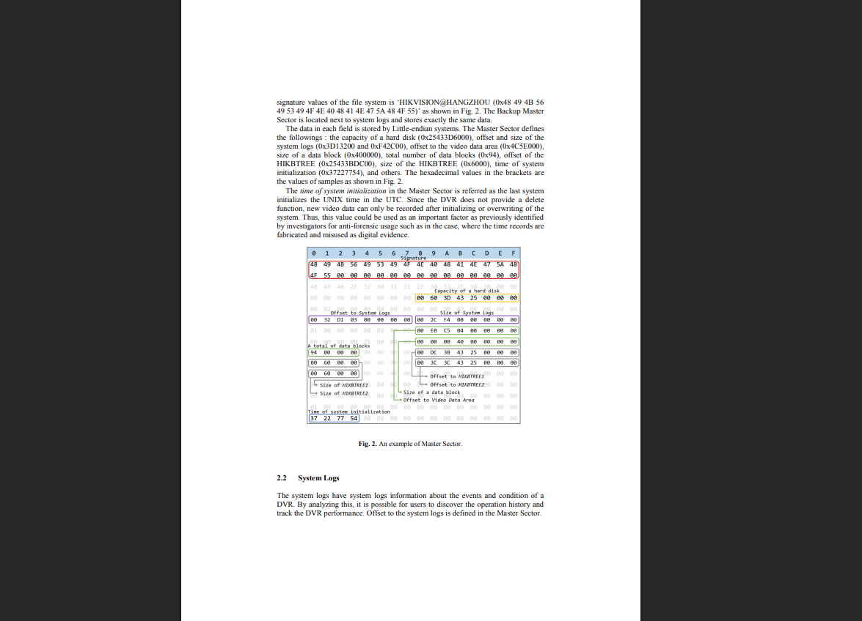
Figure 39:Research articles for Hikvision3
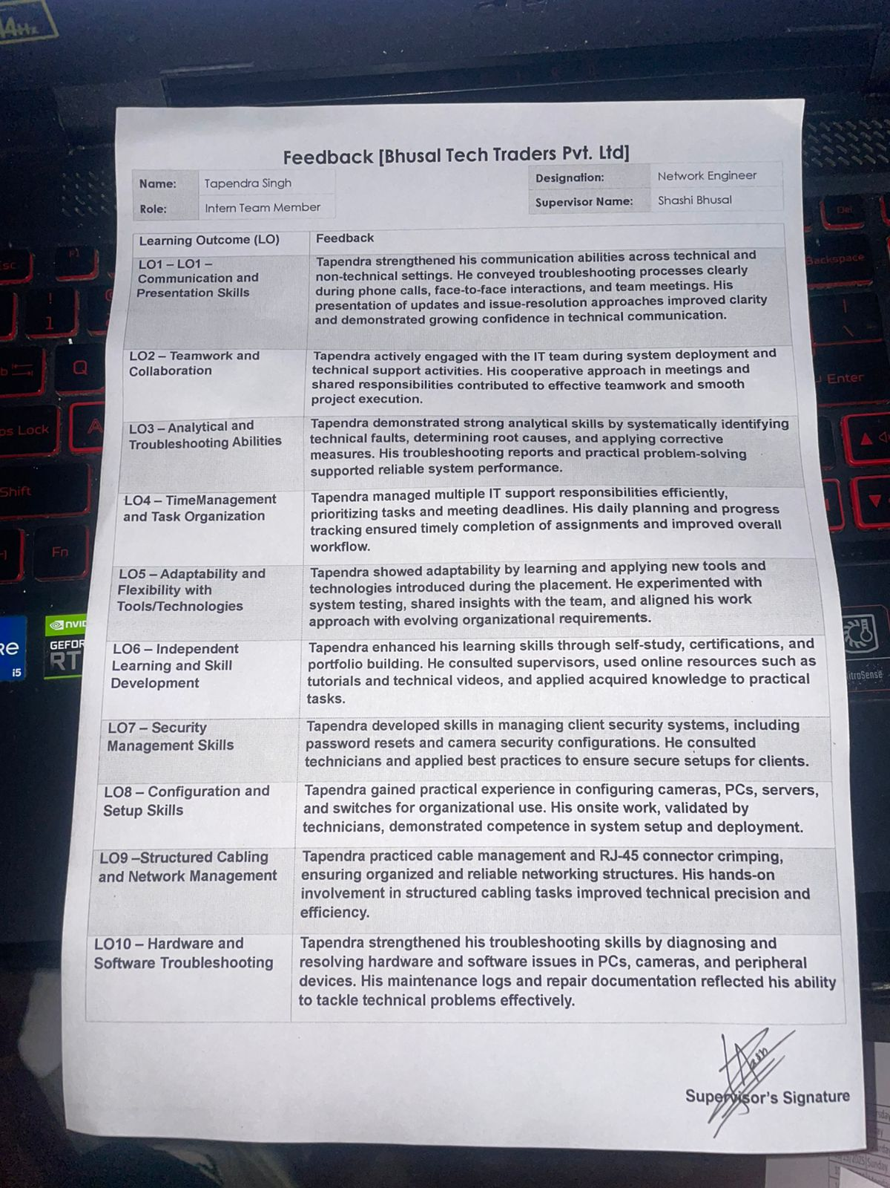
Figure 40:Feedback report

8.5.7 Log7

